 | INTERNSHIP PROJECT SUBMISSION GUIDE 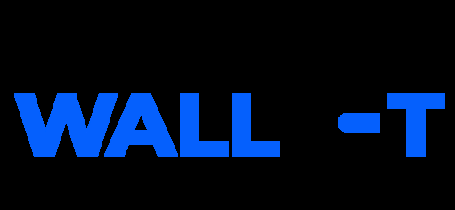  OPTICROP: SMART AGRICULTURAL PRODUCTION OPTIMIZATION ENGINE
SAMPLE PROJECT DOCUMENTATION
PROJECT USER & SYSTEM MANUAL
Team ID: 12344 | Project Name: Opticrop Date: July 7, 2026
1. Source Repository & Cloning:
- | GitHub | Repository | Link:
https://github.com/goutham-05-raj/OptiCrop-Smart-Agricultural-Production-Optimization-Engine- Clone Command:
git clone https://github.com/goutham-05-raj/OptiCrop-Smart-Agricultural-Production-Optimization-Engine
2. Installation & Setup Instructions:
- Step 1: Open a terminal inside the project directory.
- Step 2: Initialize a python virtual environment:
python -m venv .venv
- Step 3: Activate the virtual environment:
Windows (PowerShell): .venv\Scripts\Activate.ps1
Mac/Linux: source .venv/bin/activate
- Step 4: Install dependencies:
pip install -r requirements.txt
- Step 5: Generate dataset and train models:
python generate_datasets.py
python train_models.py
- Step 6: Start the Flask application server:
python app.py
- Step 7: Open 'http://localhost:5000' in a web browser.
3. Operating Instructions:
- Input fields: Enter values for Nitrogen, Phosphorous, Potassium, temperature, humidity, pH, and rainfall.- Select geographic region and planting season.
- Click 'Execute Production Optimization'.
- Result page displays recommended crop, expected yield (tons/hectare), soil cluster, and nutrient action plans.- Navigate to 'Performance Analytics' to check model evaluation charts.
Page 1 | OptiCrop Project Documentation

